Tutorial 1 MT264

Tutor : Rifat Hamoudi
Staff No. : 00567451
Pager No. : 0781-2796265

I have put this tutorial on the web. This tutorial can be viewed and downloaded from http://www.rifathamoudi.co.uk then selecting MT264 Tutorials then Tutorial 1.

1) Explain with examples what the followings are :

- Container
- Controls

2) Explain the activities during software development and suggest possible stages in the design of a simple project

3) Design and implement a Visual Basic program that adds two numbers. An example output is as shown below :

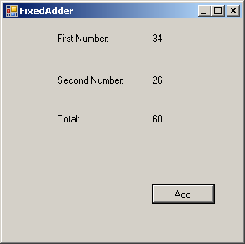

4) Design and implement a Visual Basic program that counts the number of letters in a string. An example output is as shown below :

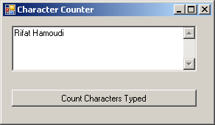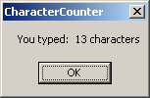

5) Design and implement a Visual Basic program that adds two numbers entered by the user. An example output is as shown below :

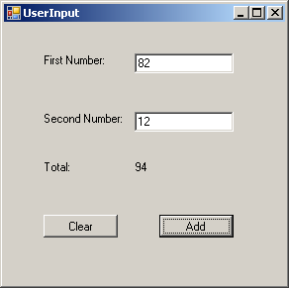

6) Design and implement a Visual Basic program that finds the occurrence of letter in a string entered by the user. An example output is as shown below :

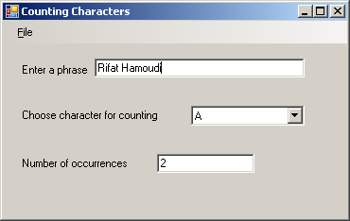

7) Design and implement functional code for a project entitled “Traffic Survey” with the following specification:

An application is required for collecting information about traffic from a particular location. More precisely, we wish to record the number of cars, bicycles and lorries passing (in either direction) a particular point at the roadside. The idea is that the user will record each car, bicycle and lorry as they pass. The application will maintain and display the total numbers of each type of vehicle.

Answer to Question 1

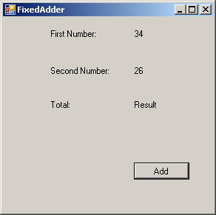

The Form “FixedAdder” is a Container

There are 7 Controls contained within it.

First Number, Second Number and Total are called Label controls

First Number Label control has Text property initialised to 34

Second Number Label control has Text property initialised to 26

Total Label control has Text property initialised to “Result”

Button control is initialised to “Add”

Answer to Question 2

Requirements analysis : This is the activity of gathering and analysing information about what the product should do and what the users’ needs are.

Specification : This is the task of formally describing and agreeing what a product will do.

Design : This is the activity of creating a solution for the specification which does not yet give the full code in a chosen programming language. Usually notations are used that allow increasingly formal levels of detail to be given as the development of the solution proceeds.

Implementation : This is the activity of coding a design and of putting together the different parts of the piece of software.

Testing : and debugging At this stage the software is run and checked. A selection of possible cases are tested to ensure that the software behaves according to the specification. Errors are corrected.

Documentation : In this activity the thoughts behind the design and implementation are written down. These explanations of the ideas behind the code are important for maintenance.

Maintenance : This is an activity that occurs after the release of the product: newly-discovered problems may need to be fixed or new/changed requirements may need to be implemented by extending or adjusting the design.

Possible stages in the design of a simple project can be summarized in the following figure :

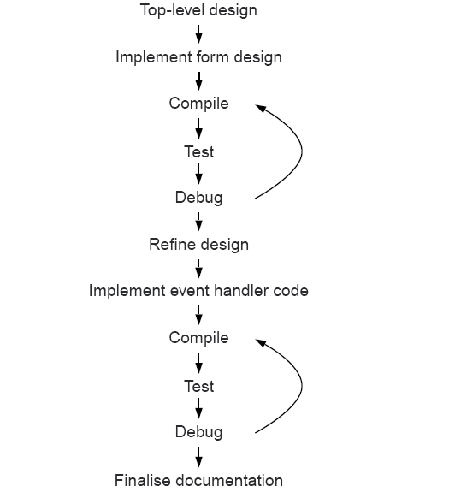

Answer to Question 3

Public Class AddForm

Private Sub AddButton_Click(ByVal sender As System.Object, ByVal e As System.EventArgs) Handles AddButton.Click

Dim FirstNum As Integer
Dim SecondNum As Integer

FirstNum = Num1.Text
SecondNum = Num2.Text

' A statement to add user input values and assign the total.
Sum.Text = FirstNum + SecondNum
End Sub
End Class

Implementation of the answer to question 3

1) File then New Project

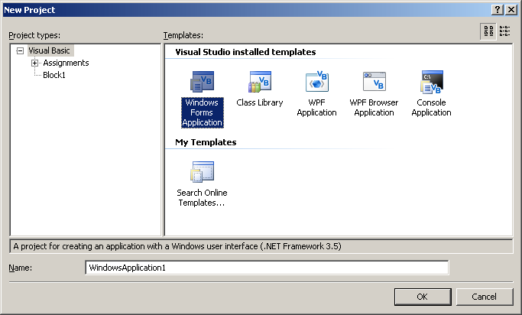

Choose “Windows Forms Application”

2)

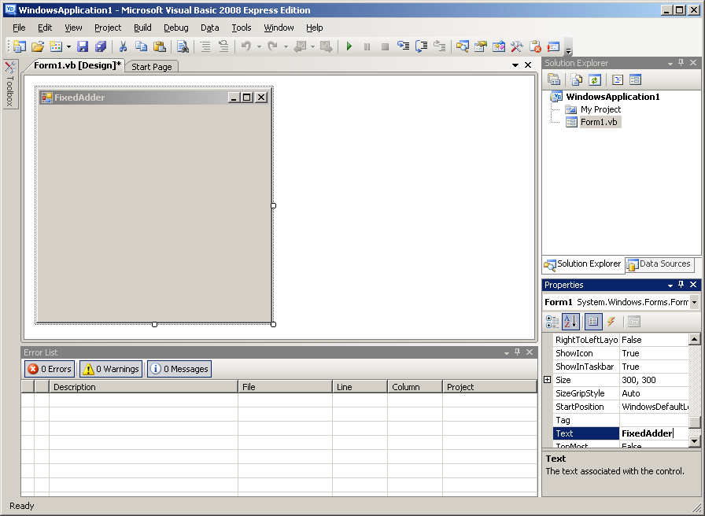

Click on Toolbar and fix it

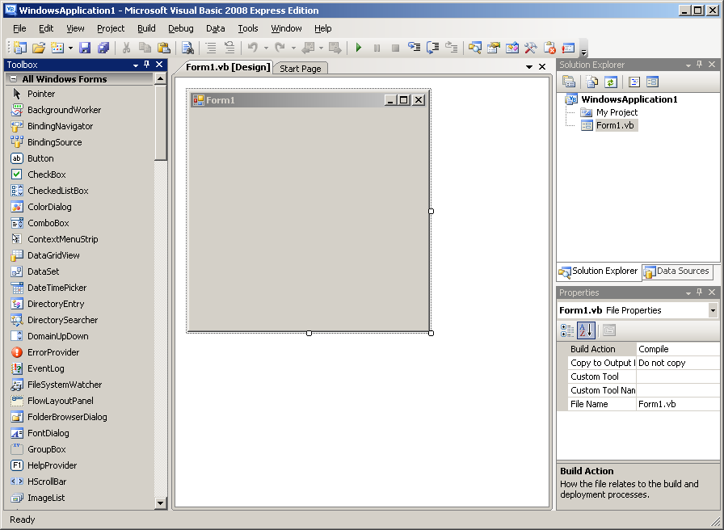

3) In this example choose 6 Label controls and 1 Button control and drag that onto the Form1 as follows :

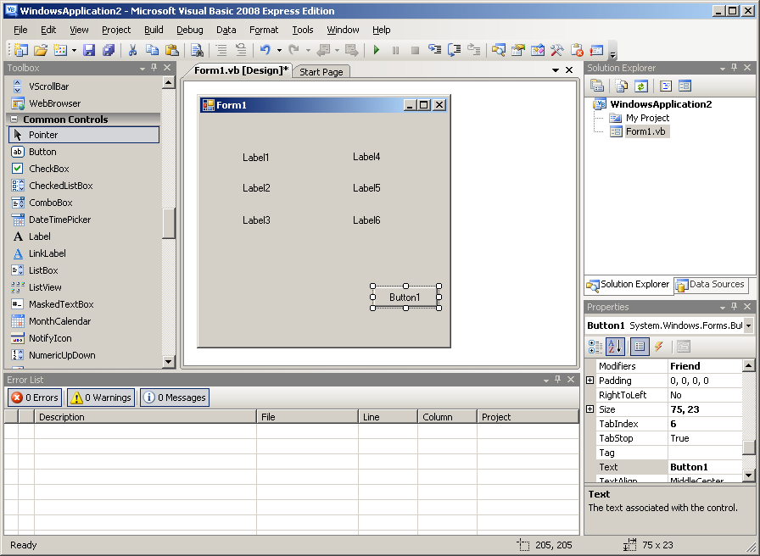

4) For the first 3 controls put the names by changing them from the Text property in the Label object. In Label4 change Text to a number for example 34. In the Button1 object change the Text to “Add” and the Name to “AddButton”.

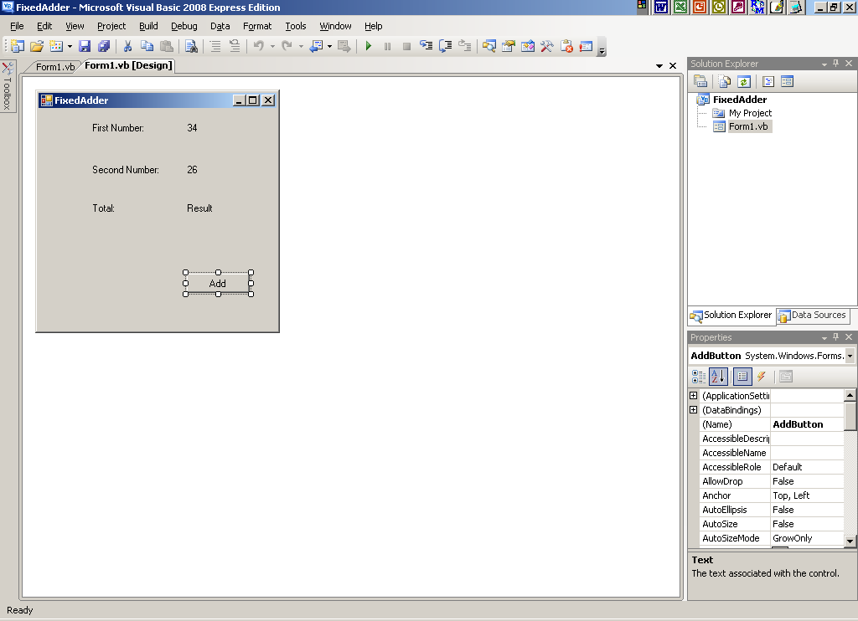

5) Double click on the Add button and you get the event handler and add the following statement :

Dim FirstNum As Integer
Dim SecondNum As Integer

FirstNum = Num1.Text
SecondNum = Num2.Text

' A statement to add user input values and assign the total.
Sum.Text = FirstNum + SecondNum

So the final code should look like this :

Public Class AddForm

Private Sub AddButton_Click(ByVal sender As System.Object, ByVal e As System.EventArgs) Handles AddButton.Click

Dim FirstNum As Integer
Dim SecondNum As Integer

FirstNum = Num1.Text
SecondNum = Num2.Text
Sum.Text = FirstNum + SecondNum
End Sub
End Class

6) Press F5 or the green button to load the software. Click on the “Add” button and you should see the addition of the 2 numbers

Answer to Question 4

Public Class Form1

Private Sub Button1_Click(ByVal sender As System.Object, ByVal e As System.EventArgs) Handles Button1.Click

' Display the character count of the textbox.
MsgBox("You typed: " & Str(Len(TextBox1.Text)) & " characters")

End Sub
End Class

The above code is the efficient type hence it is shorter but less readable. A less efficient (but more readable) code is as follows :

Dim Lengthofstring As Integer
Dim StringLength As String
Lengthofstring = TextBox1.Text.Length
StringLength = Str(Lengthofstring)
MsgBox("You typed: " & StringLength & " characters")

But the most efficient code is as follows:

Public Class Form1
Private Sub Button1_Click(ByVal sender As System.Object, ByVal e As System.EventArgs) Handles Button1.Click

' Display the character count of the textbox.
MsgBox("You typed: " & TextBox1.Text.Length.ToString & " characters")

End Sub
End Class

Answer to Question 5

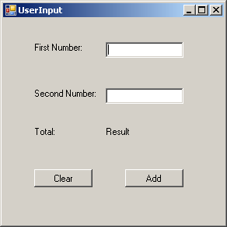

Public Class Form1

Private Sub AddBtn_Click(ByVal sender As System.Object, ByVal e As System.EventArgs) Handles AddBtn.Click

Dim FirstNum As Integer
Dim SecondNum As Integer

FirstNum = Num1.Text
SecondNum = Num2.Text

' A statement to add user input values and assign the total.
Sum.Text = FirstNum + SecondNum

End Sub

Private Sub ClearBtn_Click(ByVal sender As System.Object, ByVal e As System.EventArgs) Handles ClearBtn.Click

' Statements to resume the initial state.
Sum.Text = "Result" : Num1.Text = "" : Num2.Text = ""

End Sub
End Class

Answer to Question 6

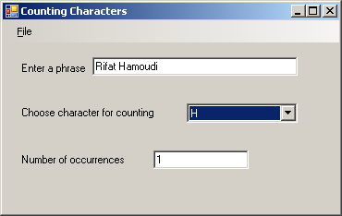

Imports MT264
Public Class MainForm
Private fCharCounter As CharCounter

Public Sub New()
fCharCounter = New CharCounter
' This call is required by the Windows Form Designer.
InitializeComponent()

' Add any initialization after the InitializeComponent() call.
charComboBox.SelectedIndex = 0
End Sub

Private Sub phraseTextBox_TextChanged(ByVal sender As System.Object, ByVal e As System.EventArgs) Handles phraseTextBox.TextChanged
'Update the current string and update the view.
fCharCounter.CurrentString = phraseTextBox.Text
updateView()
End Sub

Private Sub charComboBox_SelectedIndexChanged(ByVal sender As System.Object, ByVal e As System.EventArgs) Handles charComboBox.SelectedIndexChanged
'Display count by updating the view.
updateView()
End Sub

Private Sub updateView()
'If the phrase box is not empty then the output box is to display
'the number of times the selected character occurs in the
'entered text. Otherwise the output box is made blank.
If Not (fCharCounter.CurrentString = "") Then
outputTextBox.Text = fCharCounter.countChar(Convert.ToChar(charComboBox.SelectedItem))
Else
outputTextBox.Text = ""
End If
End Sub

Private Sub exitMenuItem_Click(ByVal sender As System.Object, ByVal e As System.EventArgs) Handles exitMenuItem.Click
Close()
End Sub
End Class

Answer to Question 7

Software design

Traffic Survey Class

TrafficS.vb

Main Form

MainForm.vb

User / Customer

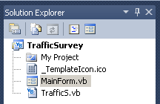

Initial state User input state

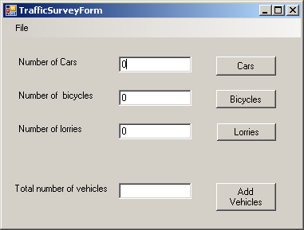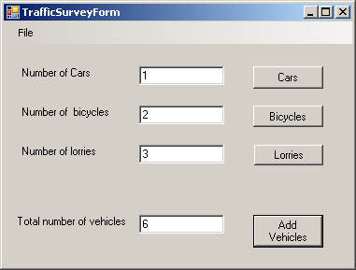

Public Class TrafficS
' Declare the fields here.

Private fCars As Integer
Private fBicycles As Integer
Private fLorries As Integer

Public Sub New()
' An instance of Traffic is created with all vehicle counts set to zero.

fCars = 0
fBicycles = 0
fLorries = 0

End Sub

' Setters

Public Sub addCar()
fCars = fCars + 1
End Sub

Public Sub addBicycle()
fBicycles = fBicycles + 1
End Sub

Public Sub addLorry()
fLorries = fLorries + 1
End Sub

'Getters

Public ReadOnly Property getCar() As Integer
Get
Return fCars
End Get
End Property

Public ReadOnly Property getBicycle() As Integer
Get
Return fBicycles
End Get
End Property

Public ReadOnly Property getLorry() As Integer
Get
Return fLorries
End Get
End Property

End Class

Public Class MainForm
Private fTrafficSurvey As TrafficS

Public Sub New()

fTrafficSurvey = New TrafficS

' This call is required by the designer.
InitializeComponent()

' Add any initialization after the InitializeComponent() call.
updateView()

End Sub

Private Sub CarsCount_Click(sender As System.Object, e As System.EventArgs) Handles CarsCount.Click

fTrafficSurvey.addCar()
Car.Text = fTrafficSurvey.getCar()
End Sub

Private Sub BicyclesCount_Click(sender As System.Object, e As System.EventArgs) Handles BicyclesCount.Click

fTrafficSurvey.addBicycle()
Bicycle.Text = fTrafficSurvey.getBicycle()
End Sub

Private Sub LorriesCount_Click(sender As System.Object, e As System.EventArgs) Handles LorriesCount.Click

fTrafficSurvey.addLorry()
Lorry.Text = fTrafficSurvey.getLorry()
End Sub

Private Sub updateView()

Car.Text = fTrafficSurvey.getCar()
Bicycle.Text = fTrafficSurvey.getBicycle()
Lorry.Text = fTrafficSurvey.getLorry()
End Sub

Private Sub AddVehicles_Click(ByVal sender As System.Object, ByVal e As System.EventArgs) Handles AddVehicles.Click

Total.Text = fTrafficSurvey.getCar() + fTrafficSurvey.getBicycle() + fTrafficSurvey.getLorry()

End Sub

Private Sub ExitToolStripMenuItem_Click(ByVal sender As System.Object, ByVal e As System.EventArgs) Handles ExitToolStripMenuItem.Click
'The application is closed.
Me.Close()
End Sub
End Class

